Import Workflow Evidence
PHASE 5 | PROJECT DEVELOPMENT AND VALIDATION
This evidence register documents the end-to-end ServiceNow spreadsheet import, field mapping, transform validation, and employee reporting workflow. It combines the supplied ServiceNow walkthrough with the five project screenshots in the repository.
Project name | Import Data using Transform Maps (Spreadsheet)
Team ID | SWTID-2026-7764
Project date | 30 September 2026
ServiceNow evidence register
No. | Workflow step | Configuration or observed result | Evidence screenshot
1 | Source workbook | Sample Spreadsheet.xlsx has the source headers Employee ID, Name, Email, Department, and Location. | 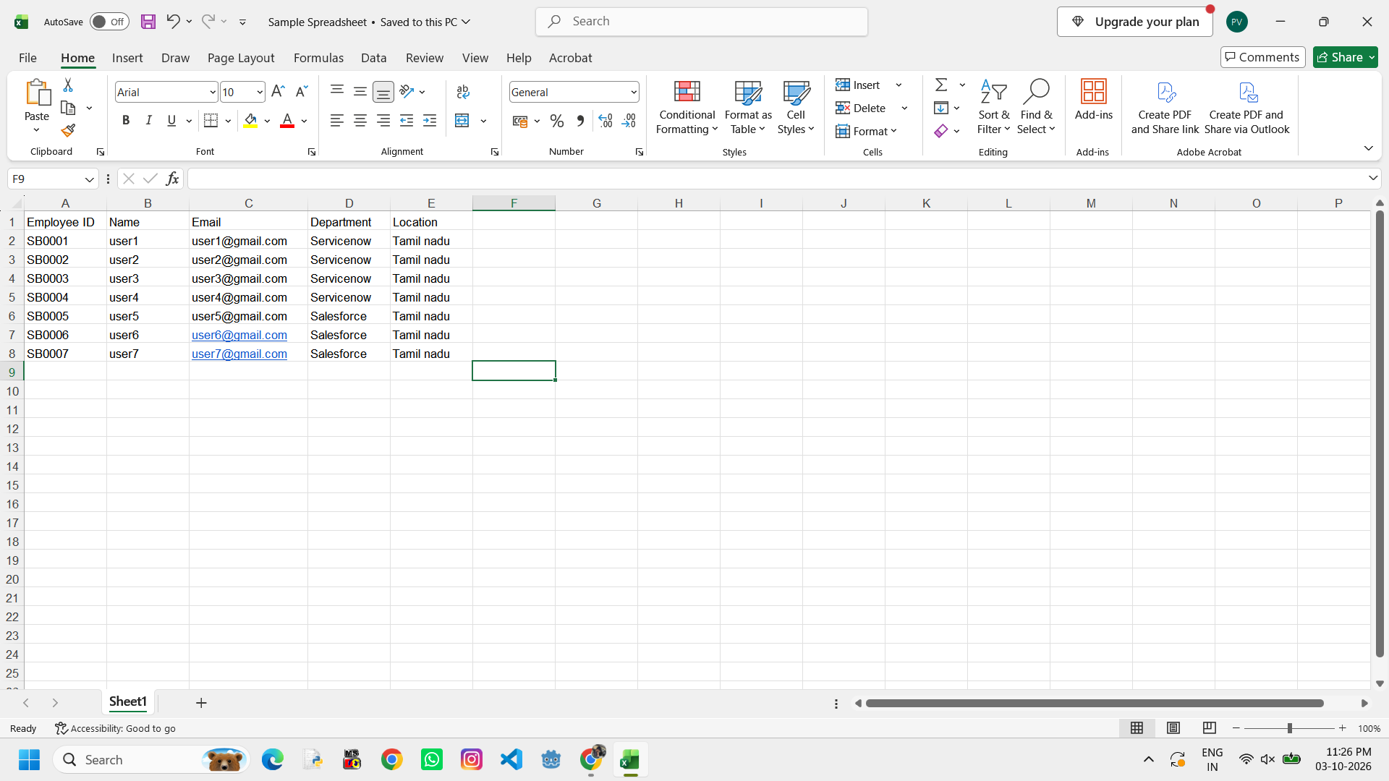  Figure 1. Source workbook.
2 | Load Data entry | Open Load Data from the ServiceNow Application Navigator to begin the spreadsheet import. | 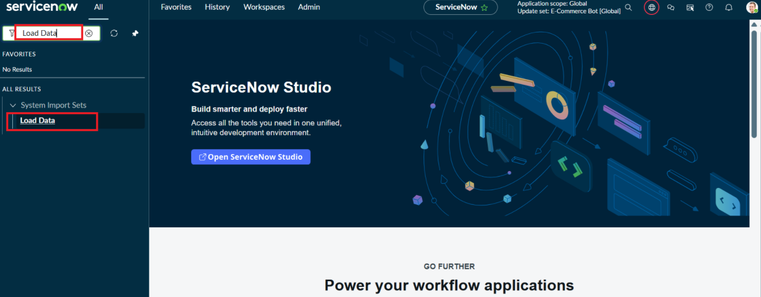  Figure 2. Load Data entry.
3 | Import Set staging | Employee Import (u_employee_import); Sample Spreadsheet.xlsx; sheet 1; header row 1. | 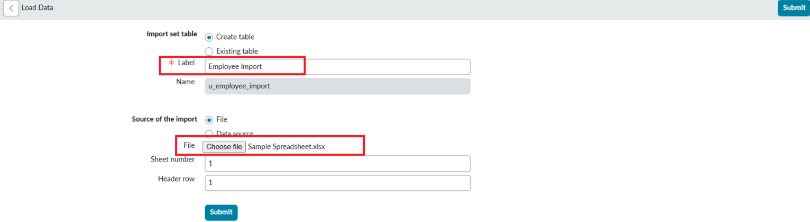  Figure 3. Import Set staging.
4 | Transform Map | Sample Spreadsheet Import connects Employee Import to Employee Test and provides the transformation configuration. | 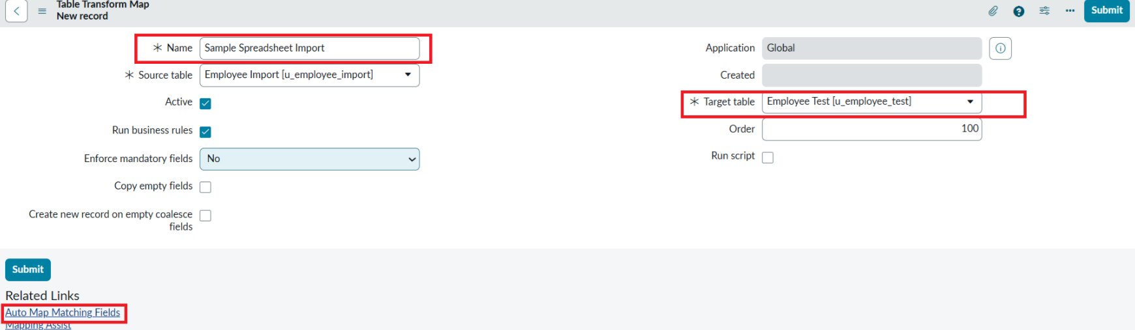  Figure 4. Transform Map.
5 | Field mapping | Map Name → Employee Name; map Employee ID, Email, Department, and Location to their same-named target fields. | 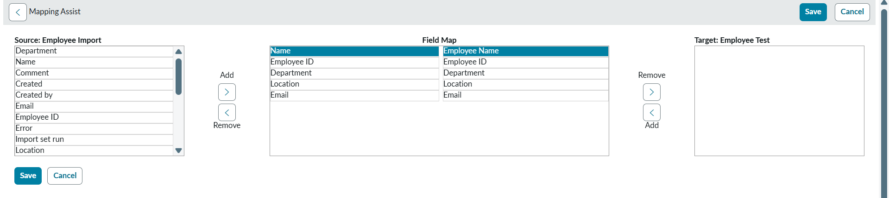  Figure 5. Field mapping.
6 | Initial transform history | The documented four-row run completed with 2 inserts, 2 updates, 0 ignored rows, and 0 errors. | 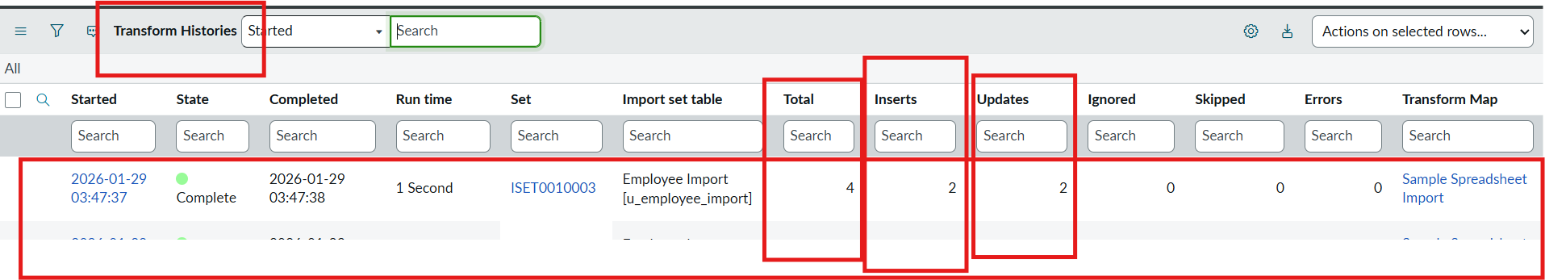  Figure 6. Initial transform history.
7 | Repeat-load coalesce | Reprocessing the same four rows produced 0 inserts, 0 updates, 4 ignored rows, and 0 errors. | 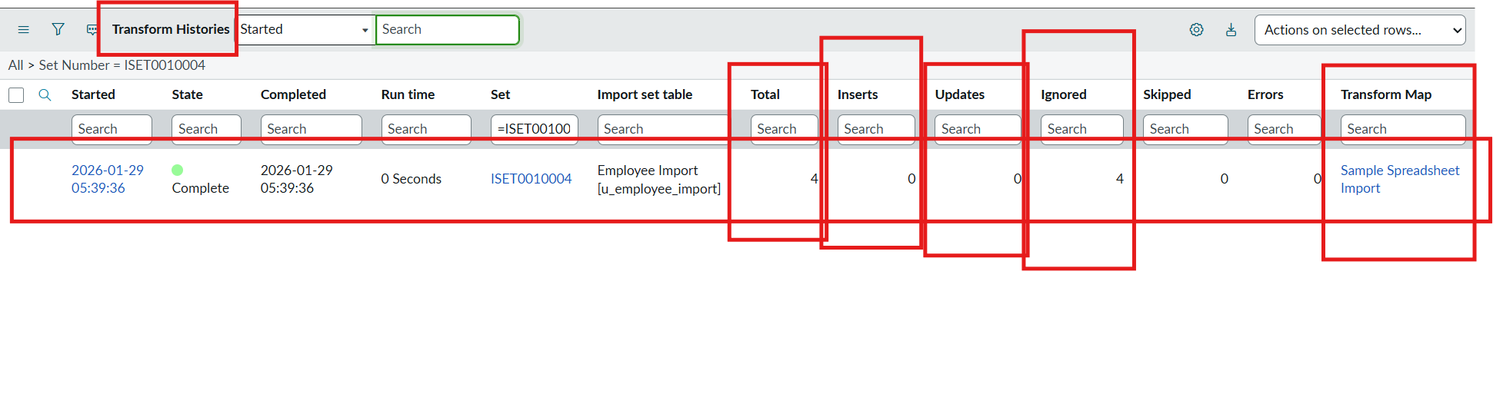  Figure 7. Repeat-load coalesce.
8 | Report inventory | The ServiceNow reports list contains Employee List Report, Employees by Location, and Employees by Department. | 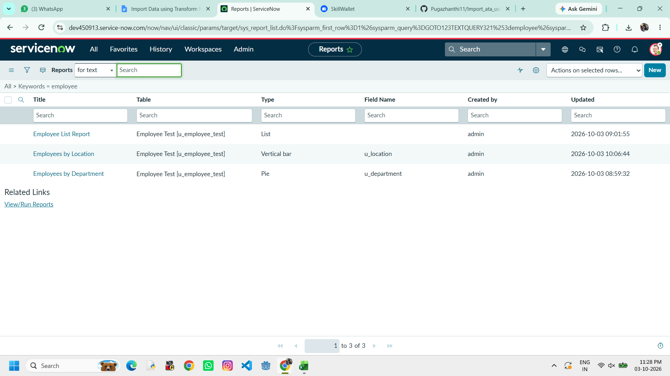  Figure 8. Report inventory.
9 | Employee List Report | List report for Employee Test with employee ID, name, email, department, and location columns. | 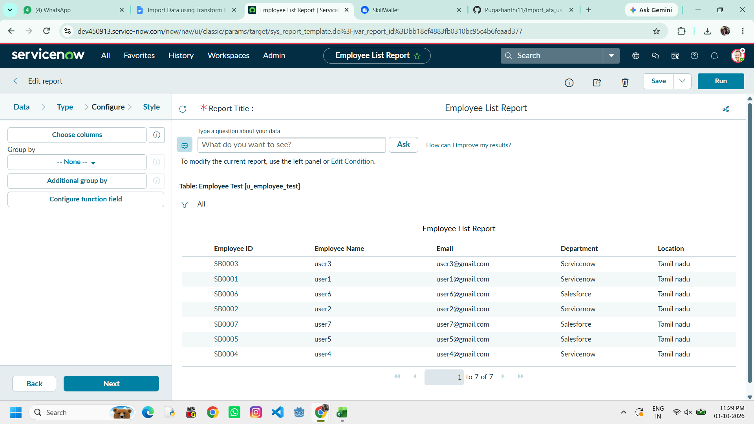  Figure 9. Employee List Report.
10 | Employees by Location | Bar report grouped by employee location, using Count as the aggregation. | 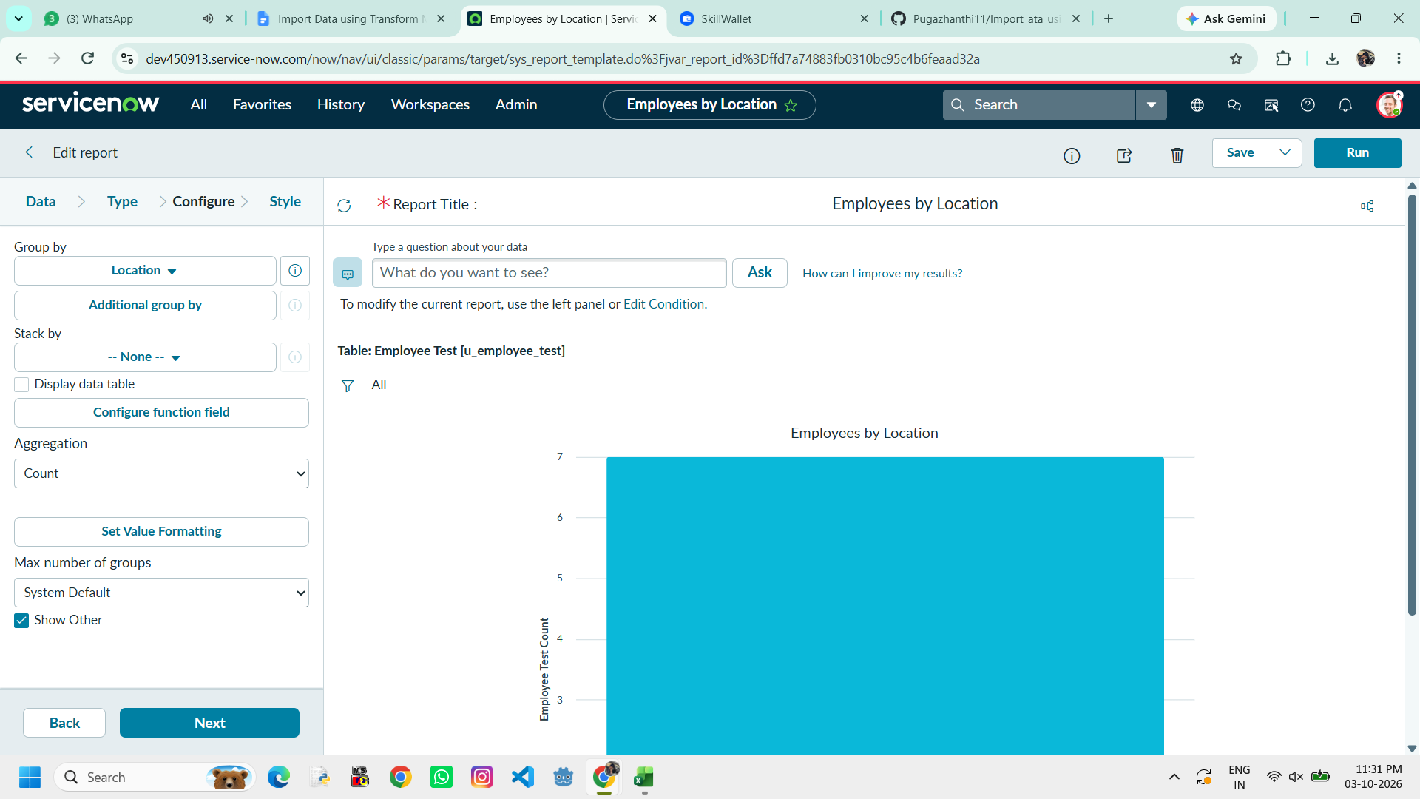  Figure 10. Employees by Location.
11 | Employees by Department | Pie report grouped by department, using Count as the aggregation. | 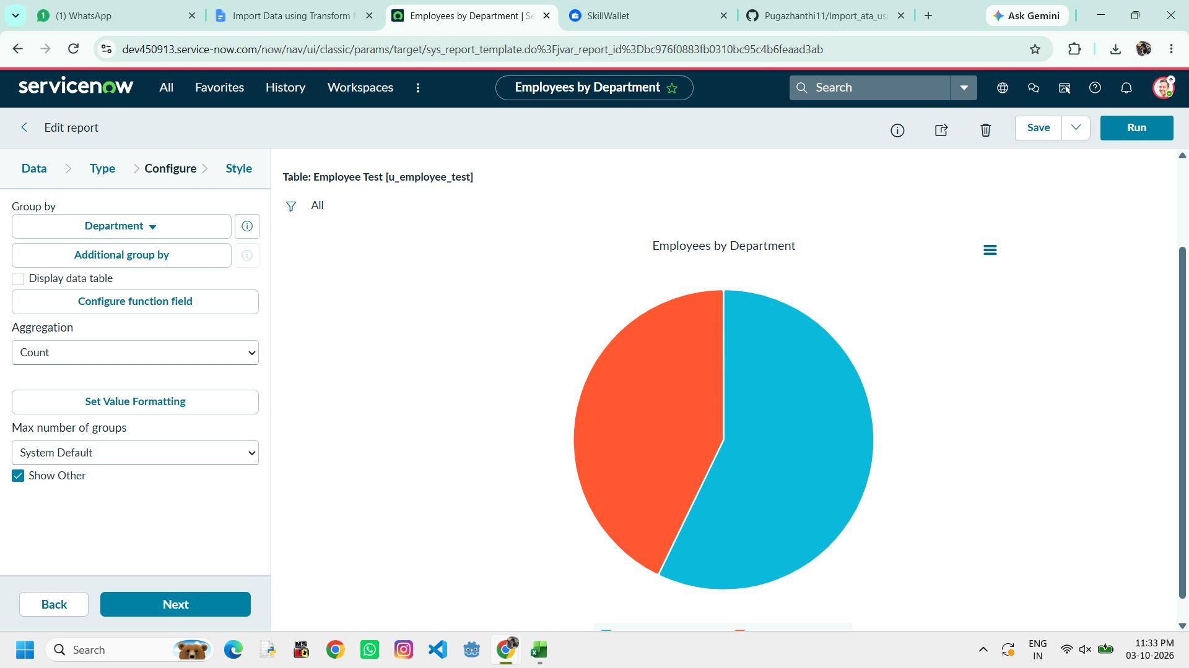  Figure 11. Employees by Department.
12 | Dashboard handoff | The project dashboard consolidates the list, location, and department reports for the intended audience. | 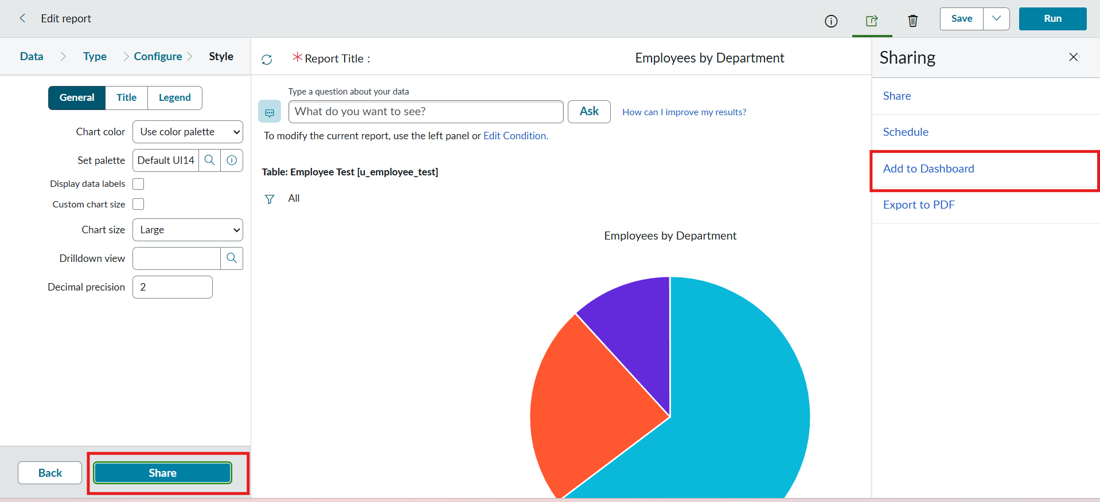  Figure 12. Dashboard handoff.
Source note: The source workbook uses Name; Mapping Assist maps it to Employee Name. Department labels visible in sample charts are data values.

